C-DAC’s Institute Of Emerging Technology (IET), PUNE

**“Online Food Donation System”**

August 2021

***Submitted By :*****Group No: 16**

|  |  |  |
| --- | --- | --- |
| 1 | Divya Mhetre | 210945920055 |
| 2 | Akshay Shende | 210945920007 |
| 3 | Aishwarya Khude | 210945920049 |
| 4 | Mahesh Nagtilak | 210945920059 |
| 5 | Akash Shedage | 210945920093 |
| 6 | Shubham Maghade | 210945920101 |

**Mr. Srinivas Dudhani**

**Project Guide**

# Table of Contents

1. Introduction 3

* Existing System
* **Proposed Food Donation Project System**
* Aims & Objectives
* Food Donation Project System Modules

1. Overall Description 5

Operating Environment

Design and Implementation Constraints

1. UML Diagram 6

1. Table Structure 7

1.Doner_info_tbl

2.Organization_info_tbl

3. worker_info_tbl

1. Conclusion 8

# Introduction

Food Donation Project System is a mission to end hunger and no wasting of food to make a hungry-free world. The focus of this project is to reduce the amount of food wasted and being used to the needy people. Therefore, a web-based application is developed by which a person can donate food with their capacity and at the same time the application lets the organization to put their request on their requirements. The basic prerequisite to use this Food Donation Project System application is a smartphone or computer.

## Existing System:

Presently people who wish to donate items need to personally visit the organizations and donate foods or other items. In general, the large manufacturers, wholesalers, and organized community provide food items to food banks or waste tons of foods daily.

They have to search for some organization that needs food. This process involves a lot of time to contact the organization to check the requirement. If they do not need the food, then the person has to contact another organization. This makes the donor tired and exhausted.

## ****Proposed Food Donation Project System:****

The application for food donation acts as an interface between the donor who are looking for a channel to give the food without wasting it. Donor can donate food in form of packets. Organization can also ask for help by visiting the website and providing the details about their need. Donation will be collected by volunteer who connects with donors and organization via this web application.

It is a web application which provides separate view for each user role for fulfilling their need. This platform also supports shipping management to pick up and drop food packages to different location.The donation will be safely reach to the intended organization. The project objective is to establish easy link of communication and interaction among donors and organizations.

**Aims & Objectives**

**Food Donation Project System Modules**

1. For Donor :
2. Register as donor.
3. Login as donor.
4. Donate items (Meals).
5. Organization(Which works for needy people) :
6. Register as an organization.
7. Login as organization.
8. Submit the required details and request for donation.(Meals)
9. Workers :
10. Registration for New Worker.
11. Login for the working worker.
12. Admin will assign task to worker to pick up donation (Meals) as per information provided by donor.
13. Worker will checkout the schedule provided by admin and complete the task.

## 

## Overall Description

## Operating Environment:

**Server Side:**

* + - OS: Windows
    - Database: MySQL

## Design and Implementation Constraints:

* + - The application will use JQuery, Ajax , HTML and CSS as main web technologies.
    - Several types of validations make this web application a secured one.
    - The Online donation application will be used on PCs and will function via internet or intranet in any web browser.

UML Diagram:

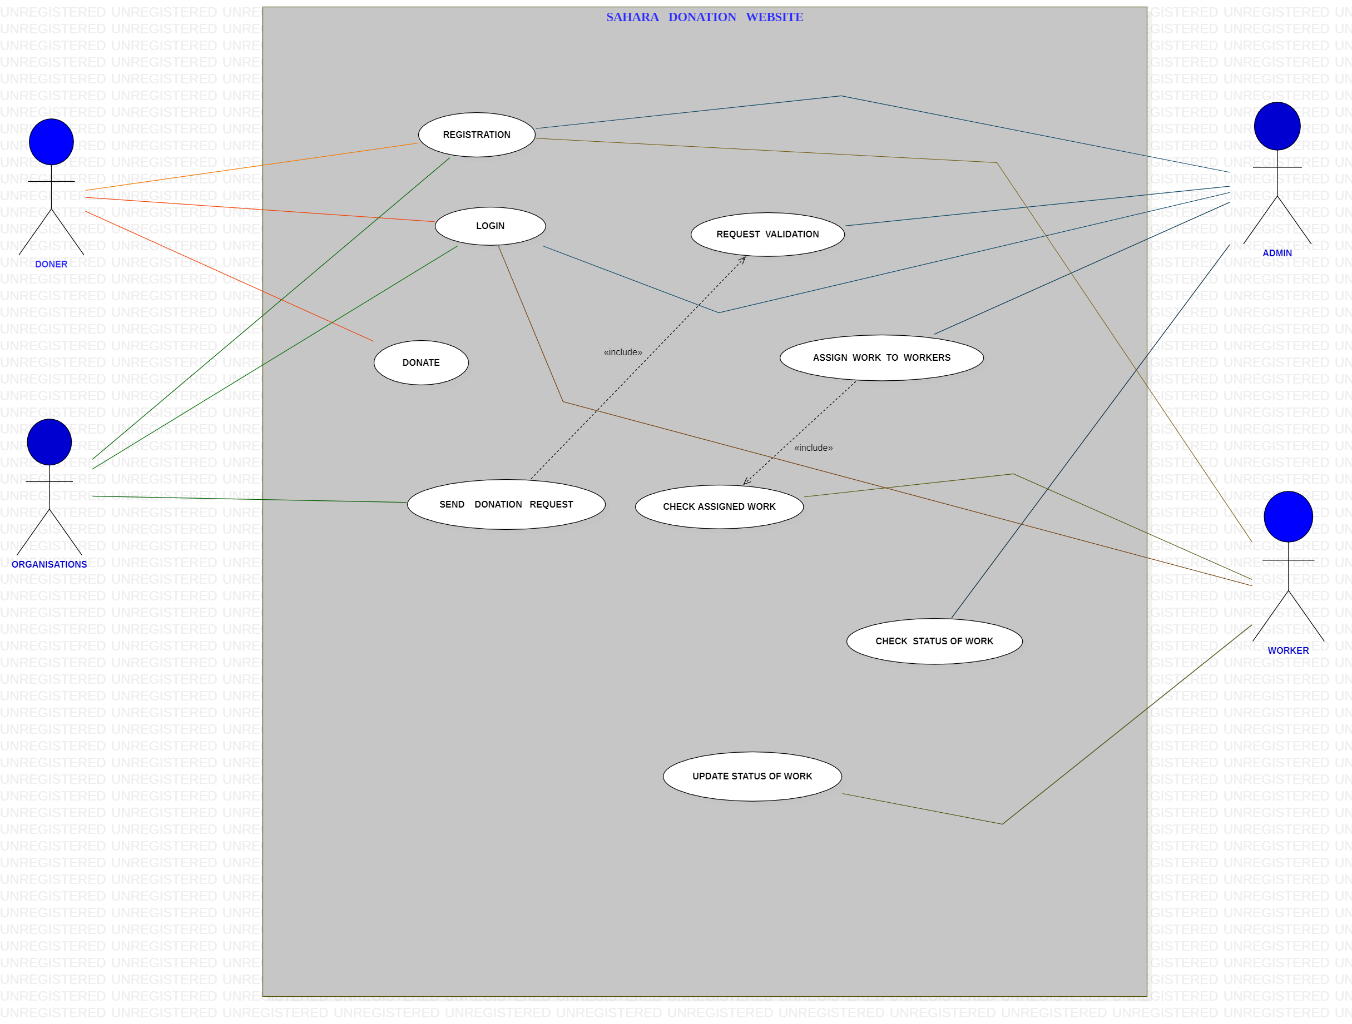

## Table Structure

## Donor_info_tbl :

## 

## Worker_info_tbl :

## 

## Organization_info_tbl:

## 

5.Conclusion :

The food can be donated easily. The visualization impact of the donation can create a positive impact on the users.  Minimizing food wastage and feeding the hunger is the main goal of the food donation project. The application is targeted in two ways, the user who is donating the food and the person/organization that is claiming the food.